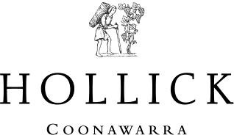

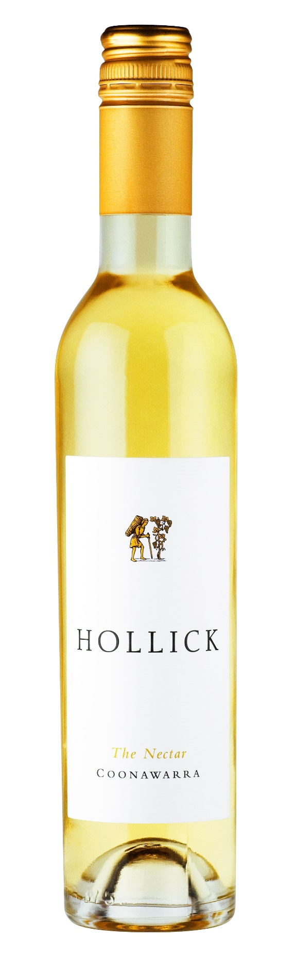
2017 ‘THE NECTAR’
It is said that the gloriously sweet, concentrated wines that result from grapes infected by Noble Rot (Botrytis Cinerea) are indeed ‘The Nectar of the Gods’. Riesling is the preferred variety for sweet botrytised wines because it retains significant acidity even with the extreme ripeness. This is a wine style which has great longevity and which will often improve for decades.

The Nectar is made from Coonawarra Riesling from our Wilgha vineyard. A cold ‘Bonney Upwelling’ at the coast moderated temperatures from January onwards. February and March temperatures were mild, and the cold nights and warm days delivered an extended ripening period. This allowed the fruit to ripen and develop intense fruit flavours. Hanging on the vines until late in the season, the harvest was delayed until the botrytis had crept its way throughout the entire vineyard. Slowly dehydrating the berries, it produced the concentrated, incredibly sweet and flavourful fruit required for making a wine of this style.

The fruit is carefully selected to ensure the integrity of the wine. Gentle pressing and a long cool fermentation retained the vibrant freshness of flavours before the wine was clarified, stabilised and bottled.
Region | Coonawarra
Appearance | Golden straw
Aromas | Lifted aromas of candied citrus and honey.
Flavours | A deliciously full round mouthfeel with stonefruit and citrus giving way to a lingering finish
Technical Details | Alc/Vol 9.5%  pH 3.6  Total Acidity 6.4 g/l  Residual Sugar 208 g/l Bottled September 2017
Cellaring | The Nectar can be enjoyed on release, but will develop complexity with 3-5 years or more of careful cellaring.
Food Matching | A thick, creamy trifle or rich chocolate fondant is sensational with a glass of The Nectar

